DJIA STOCK TIME SERIES

Abstract:

**The DJIA is a price-weighted index that tracks 30 large, publicly-owned companies trading on the New York Stock ExchangeTime-series analysis contains a set of techniques and methods to analyze time-series data and extract meaningful insights from it. On the other hand, time-series forecasting is a predictive analysis approach that predicts future values based on historical data which is collected over a period** **of time.The Dow Jones Industrial Average (DJIA), also commonly referred to as “the Dow Jones” or simply “the Dow,” is one of the most popular and widely-recognized stock market indices.. The DJIA is one of the stock indices created by Dow & Jones Company founder wall street and Journal editor Charles Dow.**

**The data is presented in a couple of formats to suit different individual's needs or computational limitations.**

**The DJIA is also used to calculate other important stock market indexes, such as the Dow Jones Transportation Average and the Dow Jones Utility Average.**

**Time series data is a sequence of data points in chronological order that is used by businesses to analyze past data and make future predictions. These data points are a set of observations at specified times and equal intervals, typically with a datetime index and corresponding value**

*METHODOLLOGY*

* ***MultiLinearRegression***

**Multiple linear regression (MLR), also known simply as multiple regression, is a statistical technique that uses several explanatory variables to predict the outcome of a response variable**

**Multiple Linear Regression is one of the important regression algorithms which models the linear relationship between a single dependent continuous variable and more than one**

**A multiple regression model extends to several explanatory variables.**

* ***RandomForestRegression***

**Random forest is a type of supervised learning algorithm that uses ensemble methods (bagging) to solve both regression and classification problems. The algorithm operates by constructing a multitude of decision trees at training time and outputting the mean/mode of prediction of the individual trees.**

**Random Forest is also a classic example of a bagging approach as we use different subsets of data in each model to make predictions.**

***Importing modules***

Import pandas as pd

**from** sklearn.model_selection **import** train_test_split

**from** sklearn.linear_model **import** LinearRegression

**from** sklearn.metrics **import** confusion_matrix,accuracy_score

**from** sklearn.ensemble **import** RandomForestRegressor

***Reading the Dataset***

**import** pandas **as** pd

df**=**pd**.**read_csv("C:\\Users\\GPT BANTWAL\\AI&ML\\AABA_2006-01-01_to_2018-01-01.csv")

df

**output:**

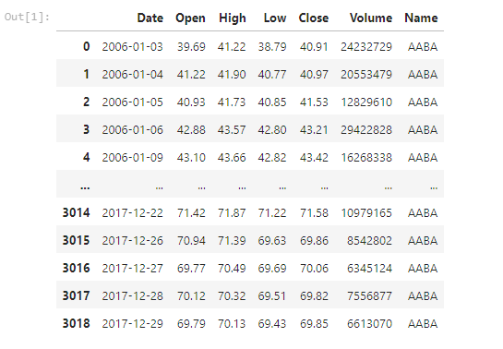

***check the five columns***

df**.**head()

**output:**

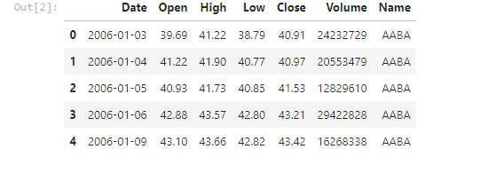

df**.**shape

**output:**



***Check the missing value***

df**.**isnull()**.**sum()

**output:**

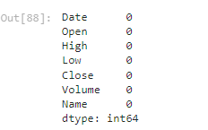

df**.**isnull()**.**any()

**output:**

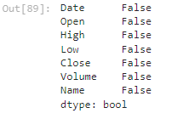

***Checking the information Dataset***

df**.**info()

**output:**

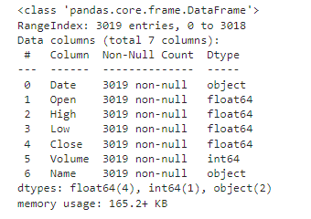

df**.**describe()

**output:**

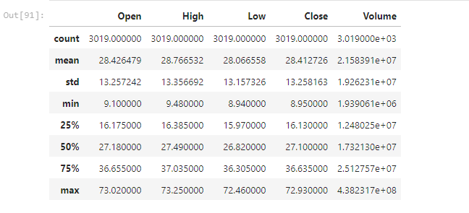

print('length of dataset:',len(df))

**output:**



x**=**df**.**drop(['Open','Date','Name'],axis**=**1)

x

**output:**

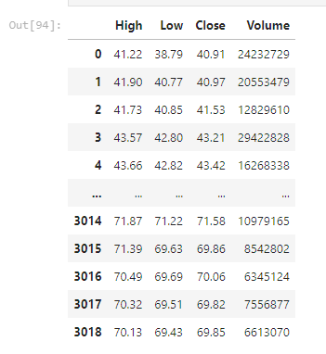

y**=**df['Open']

y

**output:**

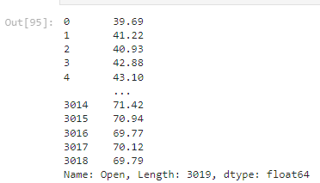

**from** sklearn.model_selection **import** train_test_split

x_train,x_test,y_train,y_test**=**train_test_split(x,y,random_state**=**0)

print(x_train**.**shape)

print(x_test**.**shape)

print(y_train**.**shape)

print(y_test**.**shape)

**output:**

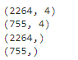

**from** sklearn.linear_model **import** LinearRegression

regressor**=**LinearRegression()

regressor**.**fit(x_train,y_train)

**output:**



print(regressor**.**coef_)

**output:**



print(regressor**.**intercept_)

**output:**



***Prediction***

predicted**=**regressor**.**predict(x_test)

predicted

**output:**

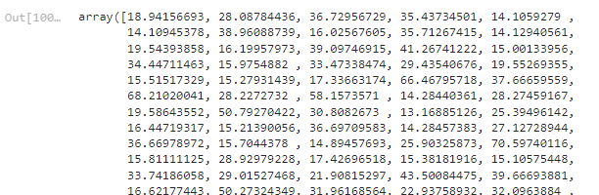

print(x_test)

print(x_test)

**output:**

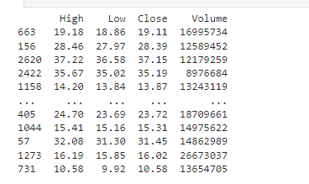

predicted**.**shape

**output:**



dframe**=**pd**.**DataFrame(y_test,predicted)

dframe

**output:**

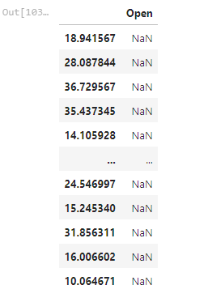

dfr**=**pd**.**DataFrame({'Actual Price':y_test,'Predicted Price':predicted})

dfr

**Output:**

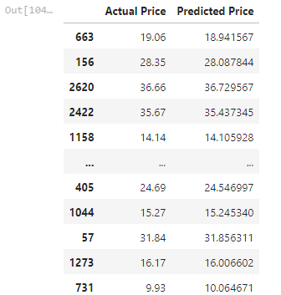

dfr**.**head(60)

**output:**

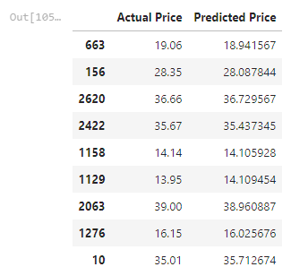

**from** sklearn.metrics **import** confusion_matrix,accuracy_score

train_accuracy**=**regressor**.**score(x_train,y_train)

print('train_accuracy:',train_accuracy)

test_accuracy**=**regressor**.**score(x_test,y_test)

print('test_accuracy:',test_accuracy)

**output:**



**import** math

**from** sklearn **import** metrics

print('Mean Absolute Error:',metrics**.**mean_absolute_error(y_test,predicted))

print('Mean Squared Error:',metrics**.**mean_squared_error(y_test,predicted))

print('Root Mean Squared Error:',math**.**sqrt(metrics**.**mean_squared_error(y_test,predicted)))

**output:**



graph**=**dfr**.**head(20)

graph

**Output:**

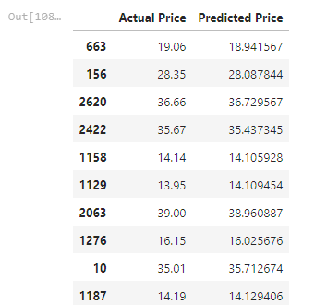

***plotting the bargraph to check difference between actualprice and predicted price***

graph**.**plot(kind**=**'bar')

plt**.**title('BarGraph')

plt**.**xlabel('Actual&prediceted price')

plt**.**ylabel('frequency')

plt**.**show()

**Output:**

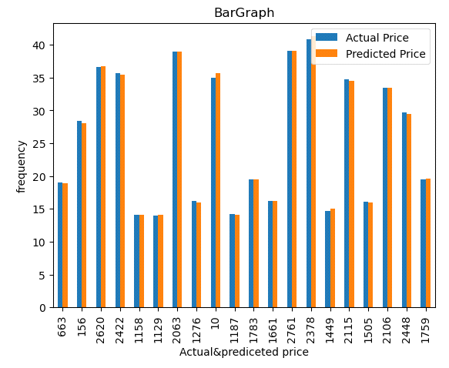

**from** sklearn.model_selection **import** train_test_split

x_train,x_test,y_train,y_test**=**train_test_split(x,y,test_size**=**0.90,random_state**=**100)

print(x_train**.**shape)

print(x_test**.**shape)

print(y_train**.**shape)

print(y_test**.**shape)

**output:**

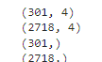

***Model trainning***

**from** sklearn.ensemble **import** RandomForestRegressor

regressor **=** RandomForestRegressor(n_estimators**=**100,random_state**=**0)

regressor**.**fit(x_train,y_train)

**output:**



predicted**=**regressor**.**predict(x_test)

predicted

**output:**



***Evaluating the model***

**from** sklearn.metrics **import** confusion_matrix,accuracy_score

train_accuracy**=**regressor**.**score(x_train,y_train)

print('train_accuracy:',train_accuracy)

R_test_accuracy**=**regressor**.**score(x_test,y_test)

print('test_accuracy:',R_test_accuracy)

**output:**



***Linear and Randomforestregression using bar plot***

**import** matplotlib.pyplot **as** plt

linear_regression_accuracy **=** 0.999700039585113

random_forest_accuracy **=** 0.998957807027415

accuracy_scores **=** [linear_regression_accuracy, random_forest_accuracy]

model_names **=** ['Linear Regression', 'Random Forest Regression']

plt**.**bar(model_names, accuracy_scores)

plt**.**xlabel('Regression Models')

plt**.**ylabel('Test Accuracy')

plt**.**title('Comparison of Test Accuracy: Linear Regression vs Random Forest Regression')

plt**.**show()

**output:**

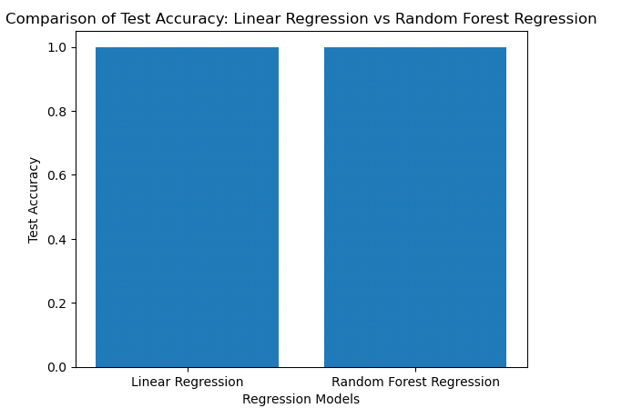**Result:**

**In this case, x-axis represents the regression models and y-axis represents the test accuracy it is comparison between linear regression and random forest regressor**

Linear Regression Accuracy:0.99

Random Forest Regressor Accuracy:0.99

**In this model Random Forest as given best accuracy, the pictorial representation of graph is shown below**

**from sklearn.preprocessing import StandardScaler**

**scaler=StandardScaler()**

**x_train=scaler.fit_transform(x_train)**

**x_test=scaler.transform(x_test)**

**ANN:**

**The term “Artificial Neural Network” is derived from biological neural networks that develop the structure of a human brain it is a type of machine learning algorithm that is designed to recognize patterns and make prediction or decision based on input data**

**from sklearn.neural_network import MLPRegressor**

**ann_model=MLPRegressor(hidden_layer_sizes=(128,64,32),activation='relu',solver='lbfgs')**

**ann_model.fit(x_train,y_train)**

**output:**

MLPRegressor(hidden_layer_sizes=(128, 64, 32), solver='lbfgs')

**In a Jupyter environment, please rerun this cell to show the HTML representation or trust the notebook.  
On GitHub, the HTML representation is unable to render, please try loading this page with nbviewer.org**

**ann_prediction = ann_model.predict(x_test)**

**ann_prediction**

**output:**

array([13.83273291, 38.31647291, 15.87872887, ..., 16.55897109,

35.62320024, 38.12609796])

**train_accuracy=ann_model.score(x_train,y_train)**

**print('train_accuracy(R_squered):',train_accuracy)**

**test_accuracy=ann_model.score(x_test,y_test)**

**print('test_accuracy(R_squered):',test_accuracy)**

**output:**

train_accuracy(R_squered): 0.9998289267069702

test_accuracy(R_squered): 0.9993325819278318

**print('Mean absolute Error:',metrics.mean_absolute_error(y_test,predicted))**

**print('Mean Squared Error:',metrics.mean_squared_error(y_test,predicted))**

**print('Root Mean Squared Error:',math.sqrt(metrics.mean_squared_error(y_test,predicted)))**

**output:**

Mean absolute Error: 0.2815740618101547

Mean Squared Error: 0.17468088426416484

Root Mean Squared Error: 0.4179484229712619

**import matplotlib.pyplot as plt**

**linear_regression_accuracy = 0.999700039585113**

**random_forest_accuracy = 0.998957807027415**

**ANN=0.9998289267069702**

**accuracy_scores = [linear_regression_accuracy, random_forest_accuracy,ANN]**

**model_names = ['Linear Regression', 'Random Forest Regression','ANN']**

**plt.bar(model_names, accuracy_scores)**

**plt.xlabel('Regression Models')**

**plt.ylabel('Test Accuracy')**

**plt.title('Comparison of Test Accuracy: Linear Regression vs Random Forest Regression vs ANN')**

**plt.show()**

**Result: In this case,the X-axis might represent the different models(linear regression,random forest regression and ANN model),while the Y-axis represents a performance matric or evaluation criterion. We have compared test accuracy(R-squred) between LinearRegression model,RandomForest Regression and ANN model using pictorial represention is shown below.**

**output:**

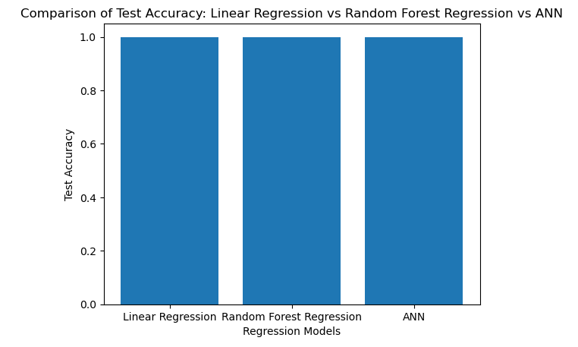

**Conclusion: In this model, we have deleted the unwanted columns which contains the NULL values, also we have the checked whether the data set contains missing values, information about the dataset , statistics the dataset . Also we have preprocess the data.In the stage of training the model,we have splited the dataset into train and test dataset, and we applied LinearRegression, RandomForest regression and ANN model and found train and test accuracy for all three models, then we compared linear regression, random forest regressor and ANN model using bargraph.In this comparesion, we got the the best accuracy in LinearRegresson Model.**